Assessing Microcirculation Condition in Critical Illness using The Pulse Oximeter’s Concept

Fatanah M. Suhaimi, J. Geoffrey Chase, Aaron J. Le Compte, Christopher G. Pretty, Rodney Elliott, Andreas Weinz
Department of Mechanical Engineering
University of Canterbury
Christchurch, New Zealand
geoff.chase@canterbury.ac.nz
Geoffrey M.Shaw
Department of Intensive Care
Christchurch Hospital
Christchurch, New Zealand
Fatanah M. Suhaimi
Advanced Medical and Dental Institute
University Science of Malaysia
Penang, Malaysia
fatanah.suhaimi@pg.canterbury.ac.nz

Normy Razak
Department of Electronics and Communication
University Tenaga Nasional
Selangor, Malaysia

Abstract—Sepsis patients normally suffer microcirculatory dysfunction, which results in organ failure and increased risk of death [1]. Importantly, microcirculatory distress is the only independent factor for predicting patient outcome if it is not treated within 48 hours [2]. Therefore, analyzing oxygen transport and utilization can potentially assess microcirculation function and metabolic condition of an individual.
In this study, pulse oximeter is used to extract additional information signals due to absorption of red and infrared light. The IR signal is related to the overall blood volume, (HbO2 + Hb) and the R signal is related to the amount of reduced hemoglobin, (Hb). Differences between these two signals thus represent the amount of oxygenated hemoglobin, (HbO2). Unlike the standard pulse oximeter, the pulse oximeter used in this study measure the changes in red and infrared signals separately.
In this study, a moderate physical exercise test has been conducted to validate the pulse oximeter concept. This test was done on healthy individuals to induce changes in extraction. This study and the use of this data was approved by the University of Canterbury Human Ethics Committee, Christchurch, New Zealand.
In this test, AC R and IR signals were relatively higher during the post-exercise compared to the baseline, due to increases in heart rate. Median heart rate increases from 51 during rest to 83 beats per minute during post-exercise 1. Further exercise yielded median heart rate of 90, 90, 91 and 99 beats per minute. In addition, oxygen extraction was also changing during the post-exercise period, indicated by the difference in the IR signal to the R signal. Median oxygen extraction increases from 37.4% during rest to 41.2% during following intense exercise. For further (repeated) physical exercise tests yielded extraction of 37.9%, 36.6%, 39.4% and 40.4%. However, the increased rate varies across subjects showing significant inter-subject variability.
The pulse oximeter sensor concept used in this study is capable of extracting valuable information to assess metabolic condition. Thus, implementing this concept on ICU patients has the potential to aid sepsis diagnosis and more accurate tracking of patient state and sepsis status.
Keywords-microcirculation; sepsis; pulse oximeter; sepsis diagnosis; oxygen extraction
This work was sponsored in part by the Advanced Medical and Dental Institute, University Science of Malaysia, NZ Tertiary Education Commission and the Government of Malaysia.

Introduction
Sepsis patients normally suffer microcirculatory dysfunction [1]. It is characterized by heterogenous abnormalities particularly in blood flow and under-perfused capillaries, which also result in, increase risk of a severe infection. Microcirculatory dysfunction drives the pathogenic effects of sepsis and results in organ failure [3] and increased risk of death [1]. In particular, microcirculatory units become hypoxic, a deficiency in the amount of oxygen reaching the tissue, which is common in sepsis patients [4-6]. As a result, the tissues and organs begin to fail. The end consequence is increased risk of the organ failure that defines sepsis. Hence, sepsis, organ failure, infection, and microcirculation failure are all related.
This study presents a non-invasive potential method to directly assess microcirculatory function that might be used to monitor critically ill patients. A pulse oximeter is used to assess microcirculation function via extraction. Extraction is the rate or level of exchange of oxygen and other products by the microcirculation. In sepsis, extraction is very low. More important, information about microcirculation dysfunction could enable better and more accurate tracking of patient state and sepsis status.
Pulse oximeter operation is based on measuring the absorption of red and infrared light passed through a patient’s finger or ear lobe. Background, such as fluid, tissue and bone, are factored out of the measurement by monitoring the steady state of absorption from bone tissue, venous blood and arterial blood. The principle of pulse oximetry is based on the assumption that the only pulsatile absorption between the light source and the photodetector is that of arterial blood. The light source incorporated in the oximeter probe consists of two light-emitting diodes (LEDs) that emit light at known wavelengths, specifically 660 nm (red, R) and 940 nm (infrared, IR). These two wavelengths are used because oxyhemoglobin and reduced hemoglobin have different absorption spectra at these particular wavelengths.
Pulse oximeter measures periodic variations produced by arterial pulsation. The periodic variations are an alternating current (AC) component, which is very small relative to the steady state direct current (DC) component. In normal use, the change in the AC signal relative to the DC signal measured represents the absorption of oxygen into tissue. The raw red and infrared signals are processed to represent the relative absorption of reduced hemoglobin and oxyhemoglobin. From this concept, oxygen saturation and extraction can potentially be derived and thus can be used to assess the status of the microcirculation. This use is a significant extension from the use of pulse oximetry to measure oxygen saturation in tissues. In particular, in this study, the changes in red and infrared signals are specifically being investigated separately unlike the standard pulse oximeter that combines all these signals into a single, calibrated oxygen saturation metric.
In this study, a physical test on healthy individuals is used to demonstrate the pulse oximeter concept. The goal is to determine if changes in oxygen extraction, a key feature of sepsis, can be assessed with good resolution under known and well understood perturbations. The use of pulse oximeter data to assess changes in oxygen extraction for an individual can therefore indicate changes in metabolic condition. Thus, the overall goal appears feasible with simple equipment that allows significant and potentially clinically important additional information to be captured.

Methods

Test Design
In this analysis, a physical test has been conducted to validate the pulse oximeter concept. The moderate physical exercise test was done on healthy individuals to induce changes in extraction. This study and the use of this data was approved by the University of Canterbury Human Ethics Committee, Christchurch, New Zealand.
In this study, subjects were required to run for at least 3 minutes on a short, flat circuit. Pre-exercise measurement was recorded for at least 30 seconds. Post-exercise measurements were also recorded for at least 120 seconds. This process was repeated (exercise and record data) for up to five laps. Fig. 1 shows the process used in this study.
In this test, changes in oxygen extraction are expected to increase during the post-exercise period, as indicated by the difference between the IR signal relative to the R signal. The IR signal is related to the overall blood volume, (HbO2 + Hb) and the R signal is related to the amount of reduced hemoglobin, (Hb). Differences between these two signals thus represent the amount of oxygenated hemoglobin, (HbO2). Depending on workout amount (laps) and intensity, changes in heart rate and cardiac output were assessed by changes in period beat to beat, ∆t, the amplitude of the AC signal, and the area under the curve of the DC signal.

Test Subject
There were 10 healthy individuals participated in the physical exercise test. Table I shows the demographic characteristics of the subjects for the physical exercise test.

Signal Acquisition and Processing
Generally, the red and infrared LED’s on the probe are alternately pulsed in a controlled fashion. The output from the photodiode of the finger probe is passed through a current-to-voltage converter. The intensity of the IR and R LED is controlled by the LED intensity control block to keep the photo-receiver sensors within specification. The raw voltage converted signal is amplified using a second stage amplifier. The signals from these two stages are fed to two different channels of ADC.
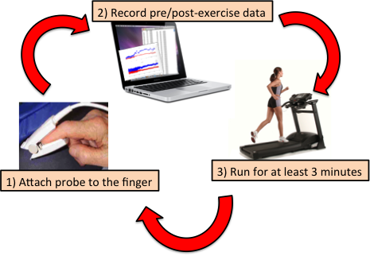
- Flowchart of physical exercise test.
- Demographic characteristic of the test subjects for physical exercise test.
Demographic Characteristics | Median [IQR]
Age (years) | 27 [23 – 29]
Gender (%)  - Female  - Male | 30  70
Weight (kg) | 72 [50 – 76]
Height (cm) | 178 [157 – 182]
Systolic blood pressure (mmHg) | 108 [100 – 110]
Diastolic blood pressure (mmHg) | 60 [55 – 70]
Heart rate (beats per minute) | 51 [48 – 57]
The sampling rate used in this experiment is approximately 70 Hz. The output data is captured from a serial port and stored in the PC. The DC component is obtained by determining a 32-point moving average of the raw signal, while the AC component is the remainder of the signal with the DC portion removed.

Results
Table II summarizes the average value of beat-to-beat (BB) interval in seconds and heart rate in beats per minute during pre-exercise and post-exercise phases for 10 subjects studied. Heart rate was significantly increased during post-exercise 1 for all subjects compared to pre-exercise. However, from post-exercise 1 to post-exercise 5, the heart rate continuously increased for some individuals, while for others, the heart rate fluctuated from post- exercise 1 to post-exercise 5. Median and interquartile range (IQR) increased from pre-exercise to post-exercise 2 and decreased during post-exercise 3, particularly for 25th percentile. Heart rate increases from a median [IQR] of 51 [48-57] during pre-exercise to 83 [75-98] during post-exercise 1. Median [IQR] changes to 90 [84-98], 90 [82-98], 91 [80-100] and 99 [76-106] during repeated physical exercise test. These differences are likely due to relative fitness and individual condition. Due to health reasons, Subject 4 was unable to complete the test until post-exercise 5.
Table III shows the average value of changes in oxygen extraction in volts and changes in percentage of oxygen extraction for 10 subjects measured during the physical exercise test. Average oxygen extraction was higher during post-exercise 1 compared to pre-exercise for most subjects. Interestingly, only Subjects 3, 7 and 10 had lower oxygen extraction during post-exercise 1 with respect to their pre-exercise. Oxygen extractions were either decreased or increased slightly from post-exercise 2 to post-exercise 5, and largely in a similar range during post-exercise phases.
Median and IQR of oxygen extraction show a similar pattern to the median and IQR of heart rate shown in Table II. Median oxygen extraction increases from 37.4% during rest to 41.2% during following intense exercise. For further (repeated) physical exercise tests yielded extraction of 37.9%, 36.6%, 39.4% and 40.4%. Again, relative fitness plays a role, as not all volunteers were equally fit.
Fig. 2 shows the change in cardiac output and change in cardiac output over time throughout the pre-exercise, and post-exercise 1, 2, 3, 4, and 5 for Subject 5. During pre-exercise, very low cardiac output was recorded compared to all post-exercise phases.

- Average value of beat-to-beat interval (BB) in seconds and heart rate (HR) in beats/minute measured during pre-exercise and post-exercises for 10 subjects studied.

No | Pre-exercise |  | Post-exercise 1 |  | Post-exercise 2 |  | Post-exercise 3 |  | Post-exercise 4 |  | Post-exercise 5
 | BB | HR | BB | HR | BB | HR | BB | HR | BB | HR | BB | HR
1 | 1.171 | 51 | 0.757 | 79 | 0.714 | 84 | 0.657 | 91 | 0.657 | 91 | 0.671 | 99
2 | 1.057 | 57 | 0.571 | 105 | 0.557 | 108 | 0.557 | 108 | 0.543 | 111 | 0.543 | 111
3 | 1.171 | 51 | 0.614 | 98 | 0.586 | 102 | 0.614 | 98 | 0.614 | 98 | 0.557 | 108
4 | 0.936 | 64 | 0.629 | 95 | 0.629 | 95 | 0.671 | 89 | - | - | - | -
5 | 1.000 | 60 | 0.800 | 75 | 0.657 | 91 | 0.629 | 95 | 0.629 | 95 | 0.600 | 100
6 | 1.257 | 48 | 0.586 | 102 | 0.614 | 98 | 0.586 | 102 | 0.571 | 105 | 0.571 | 105
7 | 1.214 | 49 | 0.757 | 79 | 0.714 | 84 | 0.729 | 82 | 0.743 | 81 | 0.786 | 76
8 | 1.143 | 53 | 0.700 | 86 | 0.671 | 89 | 0.729 | 82 | 0.700 | 86 | 0.714 | 84
9 | 1.286 | 47 | 0.800 | 75 | 0.729 | 82 | 0.750 | 80 | 0.786 | 76 | 0.757 | 79
10 | 1.314 | 46 | 1.014 | 59 | 0.971 | 62 | 0.829 | 72 | 0.829 | 72 | 0.786 | 76
Median | 1.171 | 51 | 0.729 | 83 | 0.664 | 90 | 0.664 | 90 | 0.657 | 91 | 0.671 | 99
25th percentile | 1.067 | 48 | 0.614 | 75 | 0.614 | 84 | 0.614 | 82 | 0.603 | 80 | 0.568 | 76
75th percentile | 1.257 | 57 | 0.800 | 98 | 0.664 | 98 | 0.729 | 98 | 0.754 | 100 | 0.764 | 106

- Average value of changes in oxygen extraction (HbO2) at pre-exercise and recovery for 10 subjects participated in the physical exercise test.
No | Pre-exercise |  | Post-exercise 1 |  | Post-exercise 2 |  | Post-exercise 3 |  | Post-exercise 4 |  | Post-exercise 5
 | Volts | % | Volts | % | Volts | % | Volts | % | Volts | % | Volts | %
1 | 0.082 | 33.8 | 0.063 | 42.2 | 0.066 | 31.5 | 0.047 | 32.9 | 0.047 | 32.9 | 0.020 | 25.2
2 | 0.005 | 17.9 | 0.018 | 36.7 | 0.026 | 37.4 | 0.043 | 41.7 | 0.044 | 37.9 | 0.047 | 35.8
3 | 0.022 | 50.4 | 0.031 | 41.0 | 0.043 | 45.6 | 0.041 | 37.1 | 0.018 | 38.0 | 0.070 | 48.4
4 | 0.002 | 8.7 | 0.011 | 19.1 | 0.020 | 30.9 | 0.022 | 34.1 | - | - | - | -
5 | 0.010 | 30.7 | 0.027 | 42.5 | 0.027 | 36.9 | 0.028 | 43.3 | 0.021 | 39.4 | 0.024 | 40.4
6 | 0.093 | 42.8 | 0.064 | 43.7 | 0.015 | 28.2 | 0.019 | 29.8 | 0.021 | 41.0 | 0.013 | 26.0
7 | 0.041 | 44.6 | 0.045 | 41.3 | 0.060 | 41.6 | 0.055 | 45.7 | 0.074 | 47.7 | 0.080 | 45.1
8 | 0.001 | 0.9 | 0.016 | 23.9 | 0.020 | 38.3 | 0.003 | 6.7 | 0.031 | 33.7 | 0.035 | 42.3
9 | 0.070 | 40.9 | 0.055 | 43.3 | 0.034 | 38.7 | 0.034 | 36.1 | 0.039 | 43.7 | 0.027 | 39.6
10 | 0.072 | 42.8 | 0.084 | 38.8 | 0.066 | 41.0 | 0.082 | 41.7 | 0.073 | 42.7 | 0.078 | 41.3
Median | 0.032 | 37.4 | 0.038 | 41.2 | 0.031 | 37.9 | 0.038 | 36.6 | 0.039 | 39.4 | 0.035 | 40.4
25th percentile | 0.005 | 17.9 | 0.018 | 36.7 | 0.020 | 31.5 | 0.022 | 32.9 | 0.021 | 36.9 | 0.023 | 33.4
75th percentile | 0.072 | 42.8 | 0.063 | 42.5 | 0.060 | 41.0 | 0.047 | 41.7 | 0.054 | 43.0 | 0.072 | 43.0

- Change in cardiac output (top panel) and change in cardiac output over time (bottom panel) from pre-exercise to post-exercise phases 1 to 5 for Subject 5.
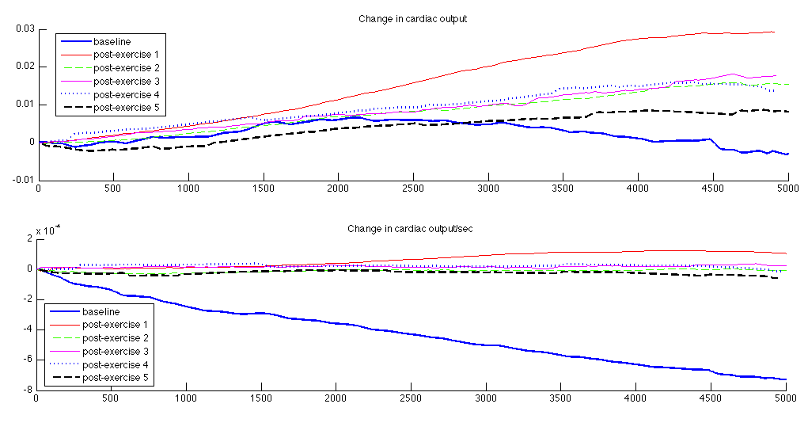
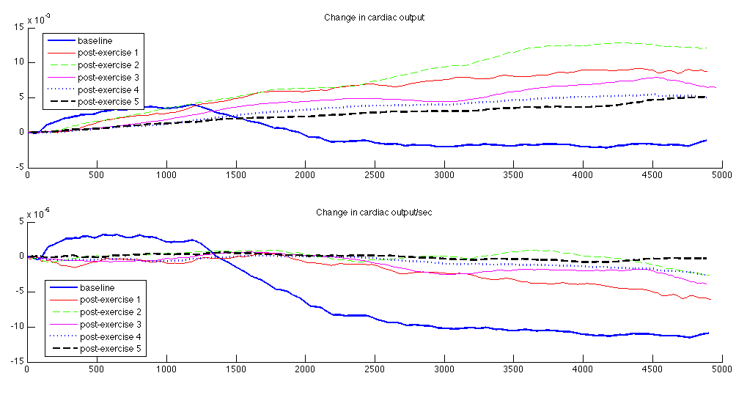
- Change in cardiac output (top panel) and change in cardiac output over time (bottom panel) from pre-exercise to post-exercise phases 1 to 5 for Subject 9.
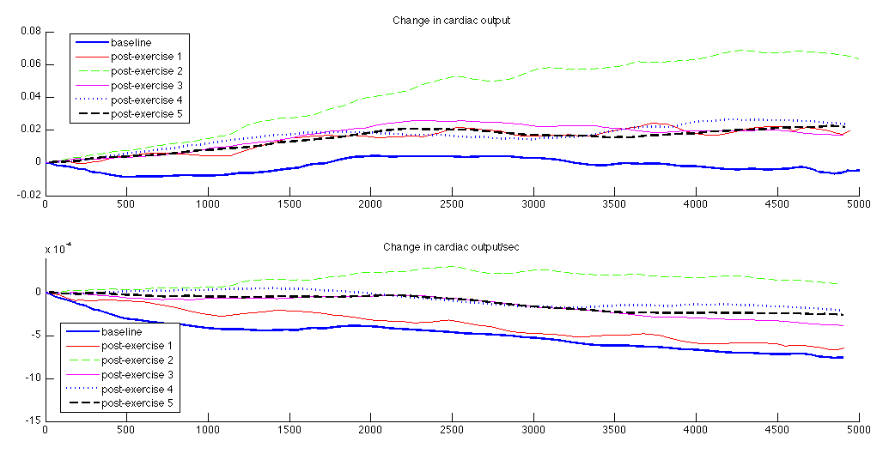
- Change in cardiac output (top panel) and change in cardiac output over time (bottom panel) from pre-exercise to post-exercise phases 1 to 5 for Subject 10.

Cardiac output increased significantly during post-exercise 1 compared to pre-exercise and continue to increase during post-exercise 2. The cardiac output began to drop during post-exercise 3 and continue to drop until post-exercise 5. In the bottom panel of Figure 9.8, there is a clear separation between the change in cardiac output over time for pre-exercise and all post-exercises.
Similarly, Fig. 3 and Fig. 4 show another example of change in cardiac output and change in cardiac output over time throughout the pre-exercise, and post-exercise phases for Subjects 9 and 10. Overall, Subjects 9 and 10 have a similar cardiac output profile as Subject 5. However, Subject 10 has a smaller gap between pre-exercise and other post-exercise phases compared to Subjects 5 and 9 illustrating the variability between individuals and fitness levels.

Discussion
Generally, much more oxygen and carbon dioxide are exchanged during exercise than at rest as exercise increases oxygen consumption and carbon dioxide production [7]. The increase in oxygen is also due to the increase in both arterial oxygen delivery and tissue oxygen extraction.
The average value of beat-to beat period and heart rate for pre-exercise and different post-exercise phases shown in Table II clearly indicate that heart rate increased largely from pre-exercise to post-exercise 1, which means from resting to doing physical activity. Heart rate continued to increase when a person increased intensity of the exercise. For some subjects, heart rate maintained at a certain level and started to decrease for the rest of the post-exercise phases, likely due to fitness level and recovery from the initial start.
Throughout exercise, hemoglobin continues to be fully saturated with oxygen particularly in people with normal respiratory function [8]. Additionally, stroke volume, heart rate and cardiac output also increase during activity. However, the increases of heart rate depend on metabolic condition, workload, duration and intensity of the physical activity [8]. At certain levels, stroke volume remained constant and further increases of cardiac output are largely due to the increases in heart rate. Hence, these two variables trade off.
The effect of exercise on oxygen extraction in healthy individuals can be seen in Table III. From the results presented, it shows that exercise increases oxygen consumption, as expected. The increases in oxygen extraction are represented by how the content of oxyhemoglobin increases over time during exercise, particularly from pre-exercise to post-exercise 1. However, from post-exercise 3 to post-exercise 5, the changes in oxygen extraction dropped and remained at this range for most subjects. This latter outcome indicates more oxygen combined with hemoglobin in blood cells initially and the amount of oxyhemoglobin reached stability later on as oxygen has been transported into the tissue. Additionally, the variation of exercise intensity and an individual fitness become factors for the resulting changes in oxygen extraction.
In particular, fitter individuals will recover and require less oxygen after the initial exercise shock. Less fit individuals will be unable to maintain effort and require less oxygen. In both cases, the pulse oximeter signals are able to identify the changes in extraction, which is the main goal, regardless of cause.
In healthy individuals, exercise increases oxygen delivery and extraction from the arterial blood. Furthermore, it also increases arterial-venous oxygen content difference [7]. However, this may not happen to sepsis patients due to microcirculatory dysfunction, such as insufficient amount of oxygen reaching the tissue, which affects the organ as well. Thus, in some disease states, oxygen demand may exceed consumption. Overall, the pulse oximeter measurements of extraction presented for the physical exercise test show it is capable of capturing these dynamics.
In addition, the changes in cardiac output for activity shown in Figures 2-4 indicate that cardiac output increases during physical activity as a result of increasing heart rate. However, cardiac output decreases slightly after post-exercise 2 or 3 depending on the metabolic condition and intensity of the physical activity done by individuals. Additionally, increases in cardiac output indicate more oxygen delivers to the exercising muscles [7]. Interestingly, the change in cardiac output is directly related to the change in oxygen extraction. Again, however, this sensor approach was able to assess relative changes in cardiac output, yielding and additional possible use.

Conclusions
Microcirculation function plays a very important and central role in the evolution of sepsis. Hence, it is well understood that sepsis directly and broadly affects microcirculatory function by reducing microcirculatory oxygen transport and tissue oxygen utilization. Therefore, analyzing oxygen transport and utilization can potentially be done by using independent signals from pulse oximetry to assess oxygen saturation and extraction.
A pulse oximeter concept was used to assess metabolic condition in healthy individuals. Instead of measuring heart rate and oxygen saturation only, the pulse oximeter was used in this study to extract additional information signals due to absorption of red and infrared light. These data are processed to measure the change in extraction at or near the microvasculature. Physical exercise is used to investigate and validate the concept on changes in metabolic condition in healthy individuals.
Heart rate and cardiac output were clearly seen to be in- creased during physical activity indicating higher oxygen extraction changes particularly from rest to exercise. Both parameters were generally increased when exercise was continuously done. However, the increased rate varies across studied subjects since it depends on the metabolic change and metabolic requirement of an individual.
In conclusion, the pulse oximeter sensor concept used in this study is capable of extracting valuable information to assess metabolic condition. More importantly, the tests used in this study validated the concept of this pulse oximeter based sensor approach to assess underlying changes in microvasculature response and oxygen extraction. Thus, implementing this concept and method on ICU patients has the potential to aid sepsis diagnosis. Moreover, since pulse oximeters are very widely used in ICU settings they represent a simple, non-invasive, low-cost means to monitor these patients.

Acknowledgment
The authors wish to thank all the participants for participating in this study, Dr. Geoff Shaw from Department of Intensive Care, Christchurch Hospital, Christchurch, New Zealand for his assistance, Department of Mechanical Engineering, University of Canterbury, Christchurch, New Zealand for the equipment and financial support. This work was also sponsored in part by the Advanced Medical and Dental Institute, University Science of Malaysia, Malaysia and New Zealand Tertiary Education Commission and the Government of Malaysia

References

- P. E. Spronk, D. F. Zandstra, and C. Ince, “Bench-to-bedside review: sepsis is a disease of the microcirculation,” Crit Care, 8:462–468, Dec 2004.
- Y. Sakr, M. J. Dubois, D. De Backer, J. Creteur, and J. L. Vincent, “Persistent microcirculatory alterations are associated with organ failure and death in patients with septic shock,” Crit. Care Med., 32:1825–1831, Sep 2004.
- C. Ince, “The microcirculation is the motor of sepsis,” Crit Care, 9 Suppl 4: S13–19, 2005.
- C. Lam, K. Tyml, C. Martin, and W. Sibbald, “Microvascular perfusion is impaired in a rat model of normotensive sepsis,” J. Clin. Invest., 94:2077– 2083, Nov 1994.
- D. Goldman, R. M. Bateman, and C. G. Ellis, “Effect of sepsis on skeletal muscle oxygen consumption and tissue oxygenation: interpreting capillary oxygen transport data using a mathematical model,” Am. J. Physiol. Heart Circ. Physiol., 287:H2535–2544, Dec 2004.
- C. Ince and M. Sinaasappel, “Microcirculatory oxygenation and shunting in sepsis and shock,” Crit. Care Med., 27:1369–1377, Jul 1999.
- L. Martin, Exercise Physiology. Chapter 12: Pulmonary Physiology in Clinical Practice, 1999.
- D. A. Burton, K. Stokes, and G. M. Hall. Physiological effects of exercise. 4 (6):185–188, 2004.

