PSEUDO-STATIC ANALYSIS OF PILES

SUBJECTED TO LATERAL SPREADING

Misko CUBRINOVSKI , Kenji ISHIHARA and Harry POULOS

ABSTRACT

Soil liquefaction during strong ground shaking results in almost complete loss of strength and stiffness in the liquefied soils, and consequent large lateral ground displacements. Both cyclic displacements during the intense ground shaking and development of liquefaction, and especially post-liquefaction lateral displacement due to spreading of liquefied soils are damaging for piles. Characteristics of the liquefied soils and loads on piles are significantly different during the cyclic phase and subsequent lateral spreading phase, and therefore, it is necessary to separately consider these two phases in the simplified analysis of piles. This paper describes a practical procedure for preliminary assessment and design of piles subjected to lateral spreading, and addresses key parameters and uncertainties involved.

introduction

There are several methods available for analysis of piles in liquefied soils including sophisticated finite element analysis based on the effective stress principle and simplified methods based on the pseudo-static approach. A rigorous effective stress analysis permits evaluation of seismic soil-pile interaction while considering the effects of excess pore pressure and eventual soil liquefaction on the pile response. Whereas the predictive capacity of such analysis has been verified in many studies, its application in engineering practice is constrained by two requirements, namely, the required high-quality and specific data on the in-situ conditions, physical properties and mechanical behaviour of soils, and quite high demands on the user regarding the knowledge and understanding both of the phenomena considered and particular features in the adopted numerical procedure. Provided that the above requirements are met, however, the effective stress analysis provides an excellent tool for assessment of the seismic performance of pile foundations in liquefiable soils.

For preliminary assessment and design of piles, however, a simplified analysis may be more appropriate provided that such analysis can satisfy the following requirements: i) the adopted model must capture the kinematic mechanism associated with the spreading of liquefied soils; ii) The analysis should allow us to estimate the inelastic response and damage to piles, and iii) the method should allow for variations in key parameters and assessment of the uncertainties associated with lateral spreading. Based on these premises, this paper addresses the use of the pseudo-static analysis of piles in liquefying soils and focuses in particular on its application to the analysis of piles subjected to lateral spreading.

GROUND DISPLACEMENTS IN LIQUEFIED SOILS

When analyzing the behaviour of piles in liquefied soils, it is useful to distinguish between two different phases in the soil-pile interaction: a cyclic phase in the course of the intense ground shaking and consequent development of liquefaction, and a lateral spreading phase following the liquefaction. During the cyclic phase, the piles are subjected to cyclic horizontal loads due to ground displacements (kinematic loads) and inertial loads from the superstructure, and the combination of these oscillatory kinematic and inertial loads determines the critical load for the integrity of the pile during the shaking. Lateral spreading, on the other hand, is primarily a post-liquefaction phenomenon that is characterized by very large unilateral ground displacements and relatively small inertial effects. Thus, the liquefaction characteristics and lateral loads on piles can be quite different between the cyclic phase and the subsequent lateral spreading phase.

Cyclic Ground Displacements
In order to illustrate some important features of ground displacements in liquefied soils, observations from well documented case histories in the 1995 Kobe earthquake are discussed in the following. Figures 1a and 1b show computed horizontal ground displacements and excess pore water pressures that developed in an 18 m thick fill deposit during the intense part of the ground shaking in this quake. This response is representative of the cyclic phase of the free field response of the fill deposits in areas that were not affected by lateral spreading.

Several features of the ground response shown in Figure 1 are relevant to the behaviour and analysis of piles in liquefied soils. First, the cyclic horizontal ground displacements in the

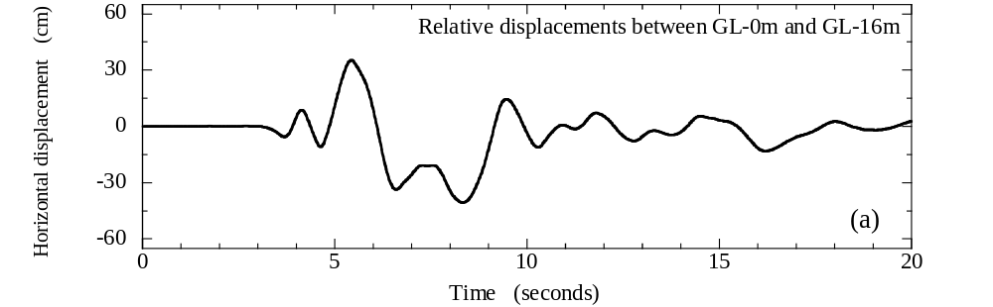

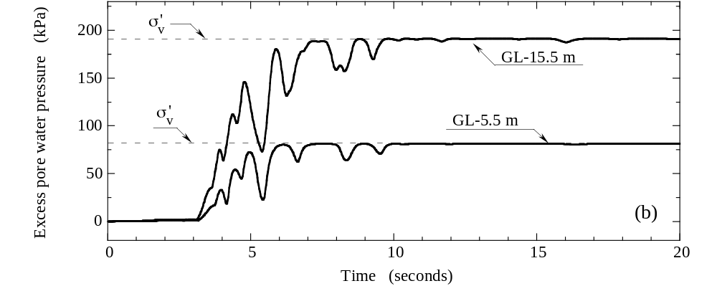
Figure 1. Ground response of liquefied deposit in the 1995 Kobe earthquake: (a) Cyclic ground
displacement; (b) Excess pore water pressure
course of the strong shaking are very large with peak values of about 35-40 cm. These displacements correspond to an average peak shear strain of about 3-4 % throughout the 10-12 m depth of the liquefied layer. Next, it is important to note that at the time when the ground displacement reached a large value of about 30 cm for the first time since the start of the shaking, i.e. at approximately 5.3 sec, the excess pore water pressure was well below the effective overburden stress thus indicating that the soil has not fully liquefied yet, at this stage. These large displacements were accompanied with high ground accelerations of about 0.4 g at the ground surface. This type of behaviour, where large ground displacements and high accelerations concurrently occur just before or at the time of development of full liquefaction, has been also observed in shake table experiments, thus highlighting the need to carefully consider the combination of inertial loads from the superstructure and kinematic loads due to ground displacements when analyzing the behaviour of piles during the cyclic phase. The magnitude of these loads depends on a number of factors including the excess pore water pressure build-up, relative displacements between the soil and the pile, and relative predominant periods of the ground and superstructure, among others. Clear and simple rules for combining the ground displacements (kinematic loads) and inertial loads from the superstructure in the simplified pseudo-static analysis have not been established yet, though some suggestions may be found in Tamura and Tokimatsu (2005) and Liyanapathirana and Poulos (2005).

Lateral Spreading Displacements
In the 1995 Kobe earthquake, the ground distortion was particularly excessive in the waterfront area where many quay walls moved several meters towards the sea and lateral spreading occurred in the backfills that progressed inland as far as 200 m from the revetment line. Ishihara et al. (1997) investigated the features of movements of the quay walls and ground distortion in the backfills by the method of ground surveying and summarized the measured displacements in plots depicting the permanent ground displacement as a function of the distance inland from the waterfront, as shown in Figure 2. Here, the shaded area shows the range of measured

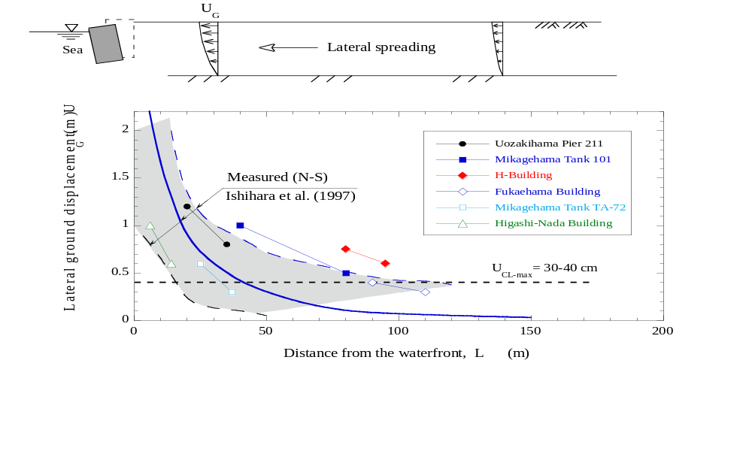 Figure 2. Permanent lateral ground displacements due to spreading of liquefied soils in
displacements along N-S sections of Port Island, and the solid line is an approximation for the average displacement. Superimposed in Figure 2 are the cyclic ground displacements in the free field showing that in the zone within a distance of approximately 50 m from the quay walls, the permanent ground displacements due to lateral spreading were significantly greater than the cyclic ground displacements. The permanent ground displacements reached about 1 - 4 m at the quay walls. Since the lateral spreading is basically a post-liquefaction phenomenon, it is associated with higher excess pore pressures and hence lower stiffness of the liquefied soils, as compared to its preceding cyclic phase. This feature, together with the unilateral down-slope or seaward ground movement, results in very large permanent spreading displacements. Clearly the magnitude and spatial distribution of ground displacements, as well as the stiffness of the soils undergoing large lateral movements, are quite different between the cyclic phase and lateral spreading phase, and these differences have to be accounted for in the simplified analysis of piles.

TYPICAL DAMAGE TO PILES

A large number of pile foundations of buildings, storage tanks and bridge piers located in the waterfront area of Kobe were damaged in the 1995 Kobe earthquake (Ishihara and Cubrinovski, 1998; 2004; JGS, 1998; Tokimatsu and Asaka, 1998). Detailed field investigations were conducted on selected piles using a borehole video camera and inclinometers for inspecting the crack distribution and deformation of the pile respectively throughout the depth of the deposit, as well as by a visual inspection of the damage to the pile head. By and large, the damage to the piles can be summarized as follows:

- Most of the piles suffered largest damage at the pile top and in the zone of the interface between the liquefied layer and the underlying non-liquefied layer (Figure 3).
- Piles in the zone of large lateral spreading displacements were consistently damaged at depths corresponding to the interface between the liquefied layer and the underlying

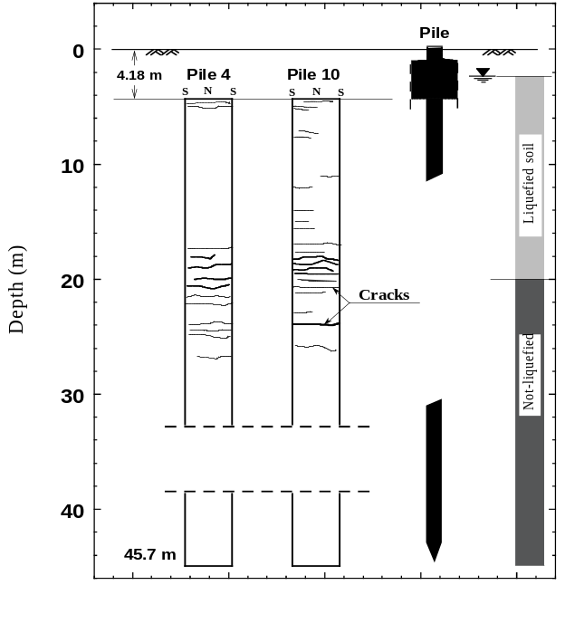
Figure 3. Typical damage to piles observed in the 1995 Kobe earthquake
(Uozakihama bridge pier P211)
non-liquefied layer. Since this interface was at large depths where inertial effects from the superstructure are known to be less significant, this damage can be attributed to the lateral loads arising from the excessive ground movement due to spreading.
- Damage at the pile head was encountered both for piles in the free field and piles located within the lateral spreading zone, near the quay walls. Both inertial loads from the superstructure and kinematic loads due to lateral ground displacements contributed to the damage at the pile head.
- The variation of lateral spreading displacements with the distance from the waterfront shown in Figure 2 may result in different lateral loads being applied to individual piles, depending on their position within the pile-group. This in turn may lead to significant cross-interaction effects and consequent bending deformation and damage to piles in accordance with these interaction loads from the pile-cap-pile system. In some cases where these pile-group effects were significant, the piles failed within the liquefied layer or at least several meters below the pile head.
In addition to the typical damage patterns described above, other less significant damage was consistently found at various depths for many of the inspected piles thus reflecting the complex dynamic nature of loads and behaviour of piles in liquefying soils.

pseudo-Static approach for simplified analysis

The most frequently encountered soil profile for piles in liquefied deposits consists of three distinct layers, as illustrated in Figure 4 where the liquefied layer is sandwiched between a non-liquefied crust layer at the ground surface and non-liquefied base layer. Liquefaction during strong ground shaking results in almost a complete loss of strength and stiffness of the liquefied soil, and consequent large lateral ground displacements. As demonstrated in the previous section, particularly large and damaging for piles are post-liquefaction displacements due to lateral spreading. During spreading, the non-liquefied surface layer is carried along with the underlying spreading soil, and when driven against embedded piles, the crust layer is envisioned to exert large lateral loads on the piles. Thus, the excessive lateral movement of the liquefied soil, lateral loads from the surface layer and significant stiffness reduction in the liquefied layer, are key features that need to be considered when evaluating the pile response to lateral spreading.

In light of the liquefaction characteristics and kinematic mechanism as described above, a three-layer soil model was adopted for a simplified analysis of piles based on the pseudo-static approach, in a previous study (Cubrinovski and Ishihara, 2004). As indicated in Figure 4, in this model the pile is represented by a continuous beam while the interaction between the liquefied soil and the pile (p-δ relationship) is specified by an equivalent linear spring (β₂k₂). Here, k₂ is the subgrade reaction coefficient while β₂ is a scaling factor representing the degradation of stiffness due to liquefaction and nonlinear behaviour. In the analysis, the spreading is represented by a horizontal free-field displacement of the liquefied soil while effects of the surface layer are modelled by an earth pressure and lateral force at the pile head, as illustrated in Figure 4. Using an iterative procedure based on the equivalent linear approach, a closed-form solution was developed for evaluating the pile response to lateral spreading. The analysis permits estimation of the inelastic response and damage to piles, yet it is based on a simple model that requires a small number of conventional engineering parameters as input (Fig. 5). Needless to say, one may use an FEM beam-spring model instead of the above closed-form solution and conduct even more rigorous analysis, as compared to the three-layer model, because it will permit consideration of a multi-layer deposit with different load-deformation properties. In principle, however, the following discussion applies to the pseudo-static analysis of piles, in general.
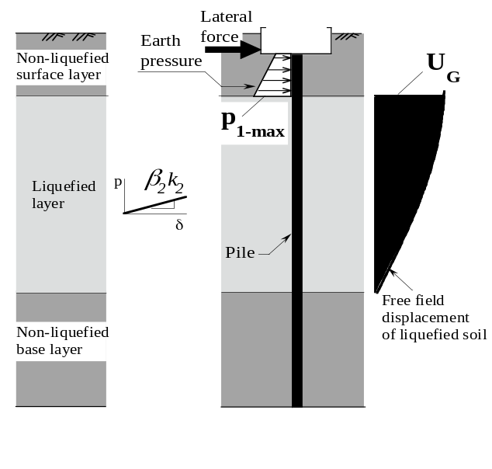
Figure 4. Simplified kinematic mechanism of lateral spreading

Input parameters of the computational model and adopted load-deformation relationships for the soil and the pile are shown in Figure 5. The equivalent linear p-δ relationship for the liquefied layer was adopted in order to simplify the modelling of the highly nonlinear behaviour of liquefied soils undergoing spreading and to allow parametric evaluation of the effects of this parameter. In the analysis of a given pile, it is envisioned that β₂ will serve as a parameter that will be varied over a relevant range of values, thus permitting evaluation of the pile response by assuming different properties of the liquefied soil. On the other hand, bilinear p-δ relationships and a tri-linear moment-curvature relationship (M-φ) were adopted for modelling the nonlinear behaviour of the non-liquefied soil layers and the pile respectively. Note that p_{1-max} defines the

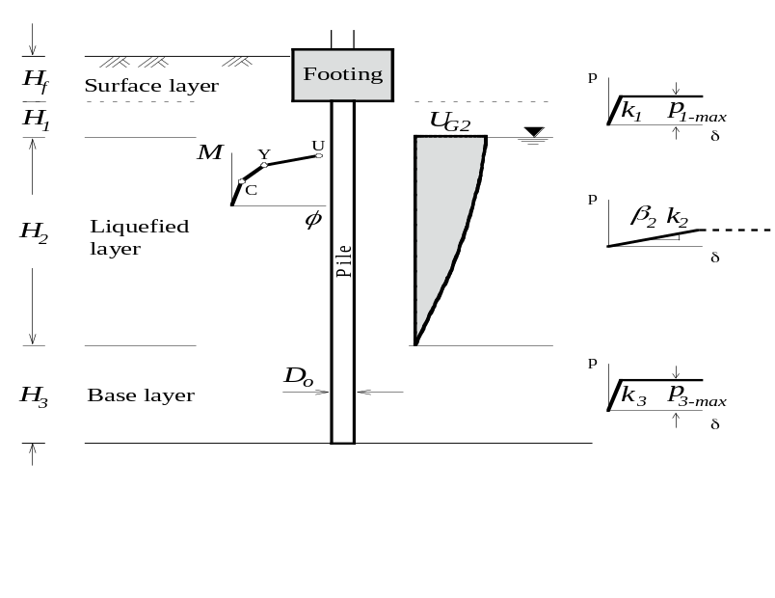

Figure 5. Characterization of nonlinear behaviour and input parameters of the model
ultimate lateral pressure that can be applied from the crust layer on the pile. In cases when the relative displacements between the soil and the pile are very large, it would be necessary to limit the maximum pressure that the liquefied soil can apply to the pile. The undrained strength or steady state strength would be one obvious choice in the definition of the ultimate pressure form the liquefied soil. This modification of the original model is indicated with a dashed line in the p-δ relationship for the liquefied soil in Figure 5.

key parameters and uncertainties involved

The analysis of piles in liquefying soils is burdened by unknowns and uncertainties associated with liquefaction and lateral spreading in particular. Thus, it is very difficult to estimate the strength and stiffness properties of liquefied soils or predict the magnitude and spatial distribution of lateral spreading displacements. One of the key aspects of the simplified analysis is therefore to properly address these uncertainties.

Lateral Ground Displacements
The lateral displacement of the spreading soil (U_{G2}) can be evaluated using empirical correlations for ground displacements of lateral spreads (Tokimatsu and Asaka, 1998; Hamada et al., 2001; Youd et al., 2002). It is important to recognize, however, that in most cases it would be very difficult to make a reliable prediction for the spreading displacements. This difficulty is well illustrated in Figure 2 where a large scatter in the ground displacements is seen, even for a single earthquake event and generally similar ground conditions. In this context, Youd et al. (2002) suggested the use of a factor of 2 for the displacements predicted with their empirical model, in order to cover the expected range of variation in the spreading displacements.

Cyclic ground displacements can be estimated more accurately by means of an effective stress analysis, but this combination of an advanced analysis being used for the definition of the input in a simplified analysis is not consistent or practical. For this reason, it seems more appropriate to estimate the peak cyclic displacements for the simplified analysis by using simplified charts correlating the maximum cyclic shear strain that will develop in the liquefied layer with the cyclic stress ration and SPT blow count, as suggested by Tokimatsu and Asaka (1998), for example. The horizontal cyclic displacement profile can be then easily obtained by integrating the shear strains throughout the depth of the liquefied layer. In both cases of cyclic displacements and spreading displacements, the lateral ground displacement that is used as an input in the simplified analysis of piles is a free field ground displacement which is unaffected by the pile foundation.

Crust Layer
The lateral load from the unliquefied crust layer may often be the critical load for the integrity of the pile because of its large magnitude and unfavourable position as a “top-heavy” load acting above a laterally unsupported portion of the pile in the liquefied soil. For the adopted bilinear p-δ relationship for the crust layer shown in Figure 5, the key input parameter is the ultimate lateral pressure, p_{1-max}.

The ultimate soil pressure from the surface layer per unit width of the pile can be estimated using a simplified expression such as, p_{1-max} = α_{u} p_{p}, where p_{p}(z₁) is the Rankine passive pressure while α_{u} is a scaling factor to account for the difference in the lateral pressure between a single pile and an equivalent wall. Figure 6 shows the variation of α_{u} with the relative displacement observed in a benchmark lateral spreading experiment on full-size piles (Cubrinovski et al., 2006) with the maximum lateral pressure on the single pile being about 4.5
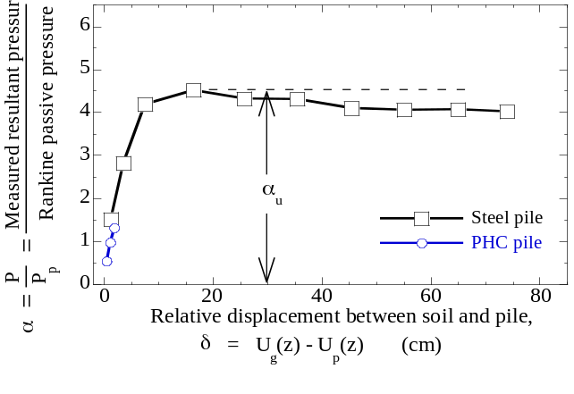
Figure 6. Ratio of lateral pressure from the crust layer on a single pile and Rankine passive
pressure, measured in full-size test using large-scale shake table

times the Rankine passive pressure. Data from other experimental studies, shown in Figure 7, also indicate quite large values for the parameter α_{u}, clearly indicating that very large lateral
loads can be applied by the crust layer to the pile. Here, it is important to distinguish between two types of loading conditions, namely, active pile loading and passive pile loading. In the case of active pile loading, the horizontal force at the pile is the causative load for the pile deformation, as shown in Figure 8a; in this case, the mobilized earth pressure provides the resisting force. In the case of passive pile loading, on the other hand, the mobilized pressure from the crust layer provides the driving force for the pile deformation, as illustrated in Figure 8b. Note that the two sets of experimental data on passive piles yield a value of α_{u} = 4.5. The test data used by Broms (1964) yielded mostly values of α_{u} = 3 – 6, and Broms adopted the lower-bound value of α_{u} = 3 as a conservative estimate for active piles. This value has been adopted in many design codes for active loading on piles, but may be unconservative for passive piles.

It is important to note in Figure 6 that a large relative displacement of nearly 20 cm was needed to mobilize the ultimate lateral pressure from the crust layer. This relative displacement du at which p_{u} is mobilized depends on the relative density of the sand, as illustrated by the

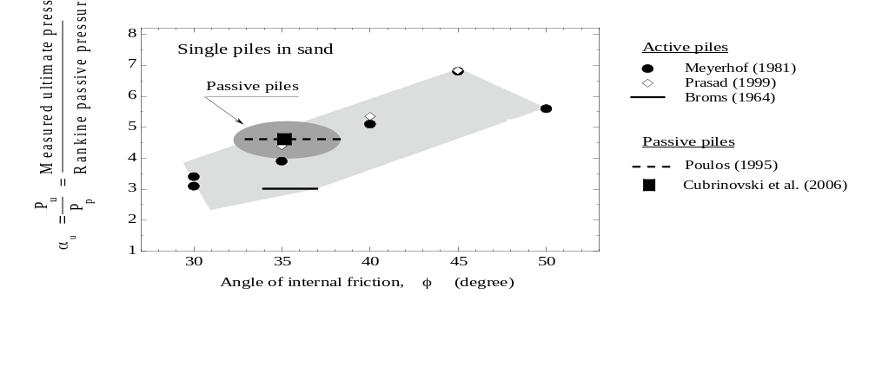
Figure 7. Ratio of ultimate pressure from the crust layer on a single pile and Rankine
passive pressure, obtained in experimental studies (Cubrinovski et al., 2005)
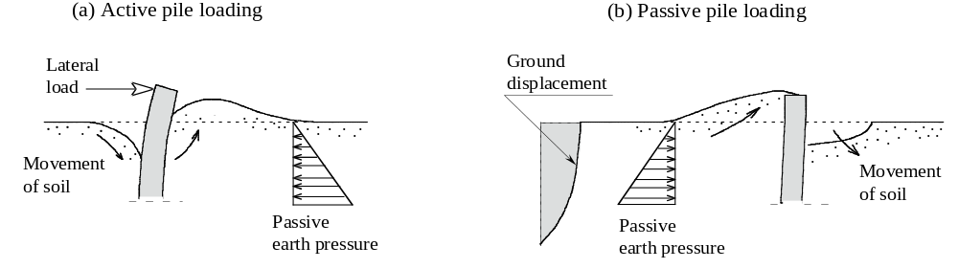Figure 8. Schematic illustration of lateral loading of piles: (a) Active-pile-loading; (b) Passive-
pile-loading

experimental data summarized in Figure 9. Here H denotes the height of the model wall or pile cap used in the test. It is evident that for dense sands with D_{r} = 70 % to 80 %, the ultimate
pressure was mobilized at a relative displacement of about δ_{u} = 0.02H to 0.08H and that larger movement was needed to mobilize the passive pressure in loose sand. Rollins (2002) suggested that the presence of a low strength layer below the surface layer may increase the required deflection to mobilize the passive pressure, and this appears to be a relevant observation for a crust layer overlying liquefied soils.

Liquefied Layer
The factor β₂, which specifies the reduction of stiffness due to liquefaction and nonlinear behaviour (β₂k₂), is affected by a number of factors including the density of sand, excess pore pressures, magnitude and rate of ground displacements, and drainage conditions. Typically, β₂ takes values in the range between 1/50 and 1/10 for cyclic liquefaction and between 1/1000 and 1/50 in the case of lateral spreading. The values of β₂ back-calculated from full-size tests on piles (Cubrinovski et al., 2006) are shown in Figure 10 as a function of lateral ground displacement, illustrating that β₂ is not a constant, but rather it varies in the course of lateral spreading.

The equivalent linear p-δ relationship for the pile, defined by the degraded stiffness β₂k₂, can be easily extended to a bilinear p-δ relationship by using the undrained or steady state strength of the soil in the definition of the ultimate lateral pressure from the liquefied soils. The empirical correlation between the undrained strength and SPT blow count proposed by Seed and Harder (1991) can be used for approximating the undrained strength in these calculations.

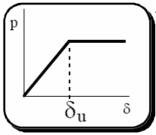
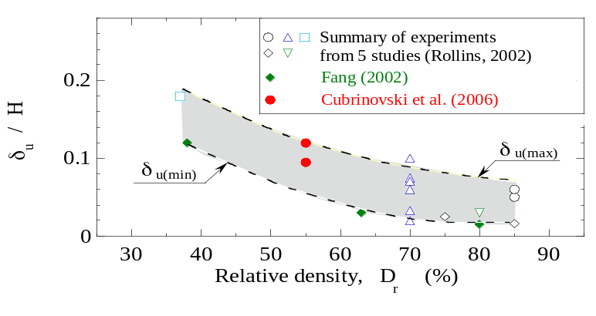
Figure 9. Relative displacement required to fully mobilize the passive pressure as a function of
the relative density of sand: summary of data from experimental studies
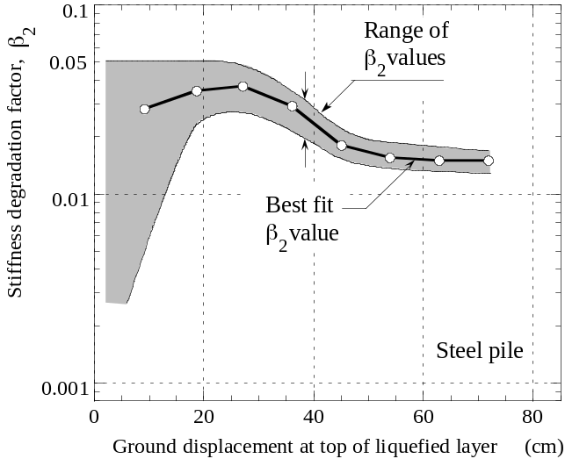

Figure 10. Degradation of stiffness in the liquefied layer as a function of lateral ground
displacement observed in full-size test on piles (Cubrinovski et al., 2006)

Pile-Group Effects
Pile groups may generally affect the behaviour of piles in liquefying soils in two ways, first through the cross interaction among the piles within the group, and second, by influencing the key parameters controlling the pile response such as the stiffness of the liquefied soils, and the magnitude and spatial distribution of spreading displacements. Both effects are briefly discussed in the following.

Piles in a group are almost invariably rigidly connected at the pile head, and therefore, when subjected to lateral loads, all piles will share nearly identical horizontal displacements at the pile head. During lateral spreading of liquefied soils in a waterfront area, each of the piles will be subjected to a different lateral load from the surrounding soils, depending upon its particular location within the group and the spatial distribution of the spreading displacements (Figure 11). Consequently, both the interaction force at the pile head and the lateral soil pressure along the length of the pile will be different for each pile, thus leading to a development of distinct

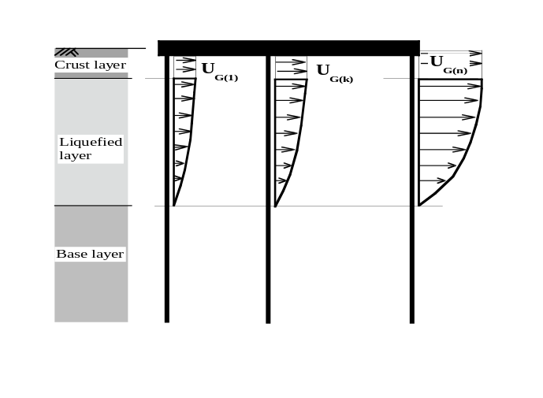
Figure 11: Piles in a group subjected to lateral ground displacements due to spreading
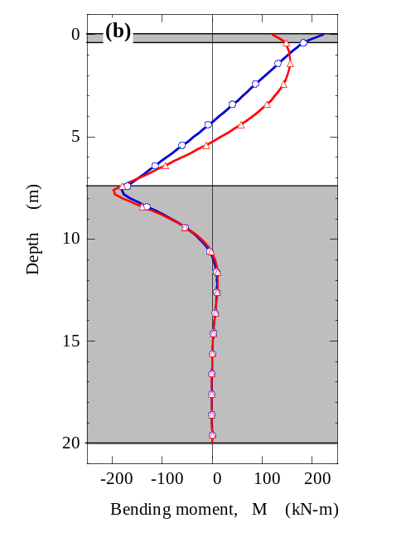
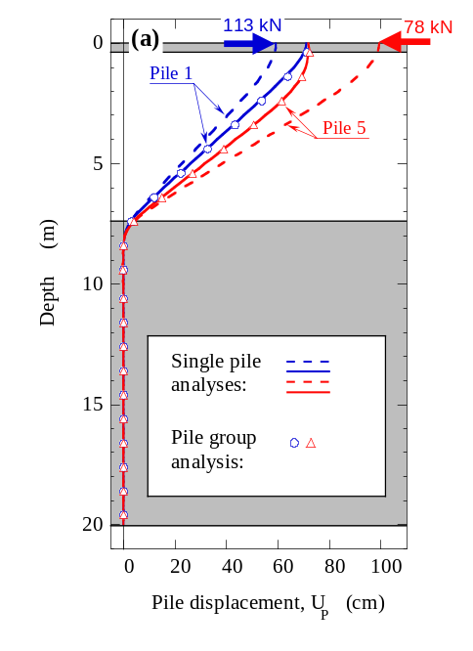

Figure 12: Illustration of cross-interaction effects on end piles subjected to different ground displacements (small ground displacement acting on Pile 1; large ground displacement acting on Pile 5); dashed lines indicate response of individual piles without cross –interaction effects; solid lines indicate response of individual piles including pile-group effects; (a) Pile displacements, and (b) Bending moments

patterns of deformation and stresses along the length of individual piles in the group (Figure 11b). This response feature, in which the piles share identical displacements at the pile head but have different deformations throughout the depth, is considered to be a significant feature of the deformational behavior of pile groups subjected to lateral spreading. These pile-group effects can be easily captured by a simplified method of analysis using a single pile model (Cubrinovski and Ishihara, 2005).

The second influence of the pile-group regarding its effects on the magnitude and distribution of ground displacements, stiffness characteristics of spreading soils and ultimate soil pressure, is more difficult to quantify. Experimental data on these effects for piles in liquefiable soils is scarce and not conclusive. Figure 13 illustrates a clear tendency for reduction in the ultimate lateral soil pressure with increasing number of piles within the group, as compared to that of an

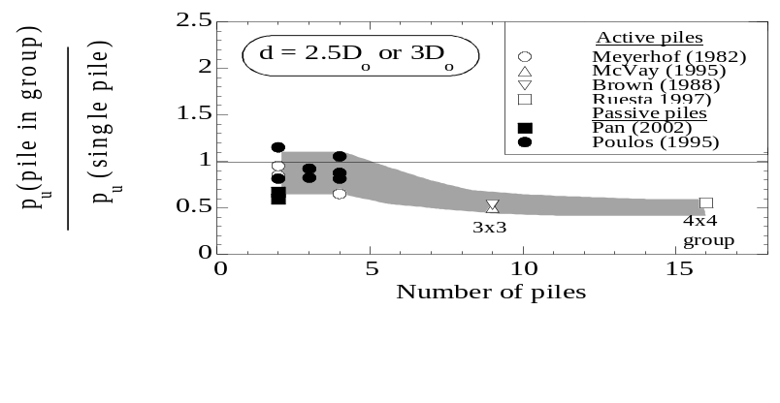
Figure 13: Reduction of lateral soil pressure due to pile-group effects
individual pile. These data are for pile spacing of 2.5-3 diameters, and include both active and passive piles, though the trend is basically derived from active piles. Further evidence for the pile-group effects on key parameters controlling the pile response in liquefying soils such as U_{G2}, β₂ and p_{1-max} discussed herein is urgently needed.

summarized procedure for pseudo-static analysis

For analysis of the cyclic phase of the pile response, key requirement is to concurrently consider the effects of ground displacements and inertial loads from the superstructure, and to properly consider the characteristics of liquefaction and subsequent ground displacements during the cyclic phase of loading. Cyclic ground displacements can be evaluated either by means of an effective stress analysis or by estimating the maximum cyclic shear strain in the liquefied soil based on empirical correlation. The inertial load from the superstructure can be simply approximated as peak ground acceleration times supported vertical load by the pile.

The proposed practical procedure for preliminary assessment and design of piles subjected to lateral spreading can be summarized in the following steps:

- A simplified three-layer model is developed for the soil deposit, where the liquefiable layer is sandwiched between a non-liquefiable crust layer at the ground surface and a non-liquefiable base layer. The water table may be used in defining the thickness of the surface layer. Properties of the base layer within 4-6 pile diameters below the interface with the liquefied layer generally control the p-δ relationship of the base layer. A single pile with a nonlinear moment-curvature relationship is adopted in this model.
- The magnitude of lateral spreading displacement can be estimated using empirical correlations for ground surface displacements of lateral spreads. In view of the uncertainties involved in the assessment of these displacements, a range of values needs to be considered. It is practical to assume a cosine distribution for the ground displacement within the liquefied soil and that the surface layer will move together with the top of the liquefied soil.
- Initial stiffness in all p-δ relationships can be defined based on empirical correlations between the subgrade reaction coefficient and SPT blow count or elastic moduli. This stiffness should then be degraded in order to account for the effects of nonlinearity and large relative displacements that are required to fully mobilize the lateral soil pressure.
- Stiffness degradation of liquefied soils is generally in the range between 1/50 and 1/10 for cyclic liquefaction and 1/1000 to 1/50 for lateral spreading.
- Ultimate lateral pressure from the crust layer can be approximated as being 4.5 times the Rankine passive pressure. The undrained or steady state strength can be used, on the other hand, for the ultimate lateral pressure from the liquefied soil.
- A static analysis in which the pile is subjected to ground displacements defined in step 2, and adopted stiffness degradation in step 4, is performed and pile displacements and bending moments are obtained. The analysis should be repeated while parametrically varying the magnitude of applied ground displacement and stiffness degradation in the liquefied soil.
- Pile group effects should be eventually considered including cross interaction among the piles within the group through the pile-cap-pile system, and effects on key parameters controlling the pile response such as the stiffness of the liquefied soils, and the magnitude and spatial distribution of spreading displacements. The latter effects may potentially reduce the severity of the ground movement influence.

conclusions

Lateral ground displacements of liquefied soils can be quite large during the intense shaking or cyclic phase of loading and especially during the post-liquefaction lateral spreading phase. Since the properties of liquefied soils and loads on piles can be remarkably different during the cyclic phase and subsequent spreading phase, it is necessary to separately consider these two phases in the simplified analysis of piles. When evaluating the pile response during the cyclic phase it is important to consider a relevant combination of kinematic loads due to cyclic ground displacements and inertial loads from the superstructure. In the case of lateral spreading, the uncertainties associated with the spreading of liquefied soils, and in particular, the magnitude and the spatial distribution of spreading displacements, and stiffness degradation of liquefied soils need to be carefully considered. The lateral load from a non-liquefiable crust layer at the ground surface may often be the critical load for the integrity of piles subjected to lateral spreading, and therefore, special attention needs to be given to the modelling of the surface layer and its effects on the pile response. Cross-interaction effects may be significant for pile foundations near the waterfront area, where individual piles within the group are subjected to variable ground displacements. Effects of group interaction on key parameters controlling the pile response need to be considered in perhaps reducing the severity of the ground movement effects. Based on these premises, a practical procedure for preliminary assessment and design of piles subjected to lateral spreading has been proposed.

References
Broms B. (1964). Lateral resistance of piles in cohesionless soils. J Soil Mech and Found Engng, ASCE; 90(SM3):123-156.
Cubrinovski, M. and Ishihara, K. (2004). Simplified method for analysis of piles undergoing lateral spreading in liquefied soils, Soils and Foundations, Vol. 44, No. 25: 119-133.
Cubrinovski, M., and Ishihara, K. (2005). Assessment of pile group response to lateral spreading by single pile analysis. ASCE Geotechnical special publication, 145: 242-254.
Cubrinovski, M., Kokusho, T. and Ishihara, K. (2006). Interpretation from large-scale shake table tests on piles undergoing lateral spreading in liquefied soils, Soil Dynamics and Earthquake Engineering, Vol. 26: 275-286.
Feng Y-S, Ho Y-C, Chen T-J. (2002) Passive earth pressure with critical state concept. J Geotech Geoenv Engng, ASCE; 128(8): 651-659.
Hamada, M., Wakamatsu, K., Shimamura, K. and Nire, T. (2001). A study on the evaluation of horizontal displacement of liquefied ground, Proc. 26th JSCE Earthq. Engrg. Symp.: 649-652 (in Japanese).
Ishihara, K, Yoshida, K. and Kato, M. (1997). Characteristics of lateral spreading in liquefied deposits during the 1995 Hanshin-Awaji earthquake, Journal of Earthquake Engineering, Vol. 1, No. 1: 23-55.
Ishihara, K. and Cubrinovski, M. (1998). Performance of large-diameter piles subjected to lateral spreading of liquefied soils, Keynote Lecture, Proc. 13th Southeast Asian Geotechnical Conf., Taipei: 1-14.
Ishihara, K. and Cubrinovski, M. (2004). Case studies of pile foundations undergoing lateral spreading in liquefied deposits, State of the art paper, Fifth Int. Conf. on Case Histories in Geotechnical Engineering, New York, CD-ROM.
Japanese Geotechnical Society (1998). Special Issue on Geotechnical Aspects of the January 17 1995 Hyogoken-Nambu Earthquake, Soils and Foundations, September 1998.
Liyanapathirana, D.S. and Poulos, H.G. (2005). Pseudostatic approach for seismic analysis of piles in liquefying soil. ASCE Journal of Geotechnical and Geoenvironmental Engineering, Vol. 131, No. 12: 1480-1487.
Meyerhof GG, Mathur SK, Valsangkar AJ. (1981). Lateral resistance and deflection of rigid walls and piles in layered soils. Can Geotech J; 18:159-170.
Prasad YVSN, Chari TR. (1999). Lateral capacity of model rigid piles in cohesionless soils. Soils and Foundations, 39(2): 21-29.
Poulos HG, Chen LT, Hull TS. (1995). Model tests on single piles subjected to lateral soil movement. Soils and Foundations; 35(4): 85-92.
Rollins KM, Sparks A. (2002). Lateral resistance of full-scale pile cap with gravel backfill. J Geotech Geoenv Engng, ASCE; 128(9): 711-723.
Seed, R.B. and Harder, L.F. (1991). SPT-based analysis of cyclic pore pressure generation and undrained residual strength, H. Bolton Seed Memorial Symposium Proc., Vol. 2: 351-376.
Tamura, S. and Tokimatsu, K. (2005). Seismic earth pressure acting on embedded footing based on large-scale shaking table tests, ASCE Geotechnical Special Publication 145: 83-96.
Tokimatsu, K. and Asaka, Y. (1998). Effects of liquefaction-induced ground displacements on pile performance in the 1995 Hyogoken-Nambu earthquake, Special Issue of Soils and Foundations, September 1998: 163-177.
Youd, T.L., Hansen, M.C. and Bartlett, F.S. (2002). Revised multilinear regression equations for prediction of lateral spread displacement, ASCE J. of Geotech. and Geoenvironmental Engrg., Vol. 128, No. 12: 1007-1017.

Senior Lecturer, University of Canterbury, Christchurch, New Zealand
Professor, Chuo University, Tokyo, Japan
Senior Principal, Coffey Geotechnics Pty Ltd, Sydney, Australia

