**Preprint version**

**Analysis of a Trial of Mentoring between Civil Engineering Students and Practicing Engineers**

Mark Milke, Civil & Nat. Res. Eng., Univ. Canterbury, New Zealand

Annelies Kamp, Educational Studies & Leadership, Univ. Canterbury, New Zealand

Dave Brierley, Canterbury Branch President, Inst. Prof. Eng. New Zealand

1. Introduction

The local branch of the Professional Engineering institution discussed with the local university’s civil engineering department the potential for future joint activities. It was agreed that a good initiative would be to trial a mentoring program involving practicing engineers and students. The civil engineering department made contact with the university department most familiar with mentoring, which was the school of educational studies and leadership. That group has great experience with teaching and research into mentoring through working with education of school teachers and a wide variety of professional groups. The aim of this paper is to provide enough detail and data from our trial to support others in the design of similar mentoring programs between engineering students and practicing engineers.

The paper briefly reviews the rich literature related to mentoring, with a focus on engineering mentoring in particular. That is followed by the details of our mentoring trial (the methods of the research), then the results of our trial, and finally conclusions in the form of the strengths of our trial, areas for improvement, lessons learned, and the future steps we intend to take.

2. Literature review

Mentoring has been used in undergraduate engineering courses in a variety of ways including research training [1], service learning [2] and building skills for culturally-diverse workplaces [3]. The complexity of the engineering profession in itself means graduates entering the industry can benefit greatly from guidance and support in some form of mentoring by a more established industry practitioner [4]. Mentoring at university is a well-studied subject [5] that supports the design of university mentoring for engineering students. Recently published research on mentoring of future engineers in the context of higher education identifies ten concepts for attention in the development of such initiatives: definition, identification of mentoring type (formal or informal), context, structure and duration, mentor characteristics, mentee characteristics, extent of ‘matching’, mentoring relation characteristics (function, phases, activities), program support and anticipated outcomes [6]. A systematic approach to the development of undergraduate mentoring programs is recommended [7], one that recognizes the benefits to both mentor and mentee [8]. The literature supported the insights gained from our visits to existing mentoring programs in committing us to a structured process that was purposely designed in collaboration with our industry partner to maximize the benefits for students and their mentors.

A wide variety of mentoring topics have been analyzed in previous studies more specific to engineering and STEM subjects, and consideration of earlier literature reinforced the potential of our trial to contribute to the experiences of undergraduate students. Research has explored the benefits for young women of mentoring them into STEM subjects [9], the role of mentors in raising young women’s persistence [10] and their retention in engineering disciplines at a higher level [11]. A positive impact on career planning in STEM disciplines has also been found for students with disabilities [12]. Undergraduate students can mentor other students considering entering the industry post-school [13] as well as their undergraduate peers [14], indicating retention benefits for both the mentee and their student mentor [15]. Related research on faculty mentoring of STEM students suggests ‘non-intrusive’ mentoring practices are effective in sustaining motivation and building a sense of autonomy [16]. Non-intrusive practices are those that are based in a notion of self-determination; the role of the mentor is not to direct mentees but, rather, to support them in arriving at their own solutions and ideas. In attaining this form of mentoring practice mentors require ‘qualifications’ that go beyond their technical background. These might include attainment of a professional level and training expertise, willingness to help, communication skills and other individual characteristics [9]. Research on a project similar to our own reports overwhelmingly positive educational impacts for undergraduate civil engineering students (n=345) in offering them role models, enhanced adaptation to industry, behavioral and attitudinal changes concerning CPD and additional access to vocational placements [7], [17]. However, as this paragraph suggests, mentoring also has the capacity to contribute to a range of strategic concerns that go beyond educational impacts including supporting initiatives around recruitment to the engineering as a career and, in particular, recruitment of higher numbers of female students and students with disabilities.

Mentoring makes a contribution to the ongoing continuing professional development (CPD) of both mentors and mentees, whatever their industry. Yet, key components of mentoring that have been identified in the literature are often unfamiliar at the level of practice. The intent of mentoring is that mentees, in our case the engineering student, arrive at their own solutions through a process of reflection facilitated by their mentor.

In designing the mentoring trial, we used a five-factor mentoring framework, drawing on the education literature.

1. The first factor is ***building rapport***. Rapport is at the heart of mentoring [18]. Rapport is when the student and their industry partner feel comfortable communicating. Mentors and students can build rapport by learning a little about the other; mentors can encourage rapport by being attentive to body language and adopting a linguistic style that mirrors that of the student.
2. The second is ***active listening***. The goal of active listening is to allow the student a chance to fully express their thoughts and feelings. Tolhurst [18] suggests there are three different levels of listening – surface, directed and listening for learning – and partners in the mentoring moment need to ensure they are ‘listening for learning’. This involves the suspension of judgement of what is being heard and simply getting as close to where the speaker is as is possible.
3. The third factor, ***effective questioning***, helps students to work out their own solutions and to make progress towards achieving their goals. Mentors can build a bank of questions that are open, challenging, visionary, exploratory and powerful such as: what would you do if you could not fail; what would you do if time and money were no object; what could you do to make this fun; what is the best possible outcome you can imagine [18]?
4. Successful mentoring involves ***clear expectations*** and this is the fourth factor. In the trial we had expectations for both students and industry mentors that facilitated shared understandings of levels of commitment and responsibilities of each partner.
5. Our final factor concerned ***goal setting***. Discussing the student’s career and professional development goals is a way to help them focus on what they want to achieve as an incoming member of the engineering industry. One of our own goals in introducing mentoring to the educational experience was to foster the ability of the student to imagine himself or herself as a committed member of the engineering industry.

3. Details of our Mentoring Trial

Local professional engineers were contacted and a list of 17 volunteers (3 women) was developed. Thirteen of the volunteer mentors were from civil engineering practice fields (structural, geotechnical, water services, transportation), and there were two electrical engineers, one mechanical engineer, and one fire engineer—all with some experience of infrastructure projects. The ages of the mentors varied greatly with 4 from 20-30, and 3 over 60 years, with an average age of roughly 42 years. The overall timetable for our Mentoring Trial is provided in Table 1.

**Table 1: Mentoring Trial Chronology**

|  |  |
| --- | --- |
| Date(s) | Activity |
| Early August 2016 | Release requests for expressions of interest to potential mentors and mentees |
| Mid August 2016 | Develop sets of expressions of interest; close off requests when full |
| Mid August 2016 | Develop materials to give participants; develop on-line resources |
| Mid August 2016 | Develop entrance and exit surveys |
| Late August 2016 | Match mentors and mentees; release entrance survey |
| Early September 2016 | Develop training session exercises and presentations; organize venue |
| Mid September 2016 | Mentor training session |
| Mid September 2016 | Meet-and-greet session |
| Mid September to Early November 2016 | Series of Mentor/Mentee dialogue meetings, held at a frequency, venue and duration as agreed between each pair. Communicate with participants via email to check on progress, issues. |
| Early November 2016 | Wrap-up session with mentors and mentees |
| October 2017 | One-year-on survey for mentees |

Students were emailed and asked to submit an expression of interest in the trial. The expression of interest needed to state their professional interests and career goals, and what they hoped to gain from the mentoring. The email was sent to both the third and fourth year students studying civil and natural resources engineering because the organizers were interested to know which group would benefit more from mentoring. Within 12 hours, 20 expressions of interest had been returned, and another email was sent requesting no further applications. A sample student response was:

I am very interested in the opportunity of becoming a mentee and would love to help in the development of this trial program.

I can see how having a mentor would be invaluable. Meeting with a mentor would provide further understanding of the engineering profession and environment, insight into gaining professional accreditation and tips for developing my career as an engineer. This opportunity also would mean I would be able to form and build a relationship with an engineer whom I can seek advice from at any time.

In terms of my professional interests and career goals, I aim to become a specialist in water engineering (i.e. the three waters) with the goal of becoming a technical director or group leader in this sector. Guidance and direction on how to achieve this along with general advice would be gratefully received from an experienced professional in this field.

Please let me know if there is any other information you would like to know.

Thank you for your consideration.

A waiting list was formed to allow a match with the (uncertain at that time) number of mentors. One application was declined because the student had not provided a genuine attempt to describe career goals or the value of mentoring. Nine third-year students were selected (five women), and eight fourth-year students (three women). Roughly 25% of the overall student cohort for the combined years were women, so the representation by women in the mentoring trial was relatively high.

Because of time constraints, it was only possible to run an eight week trial at the end of the students’ spring semester. Our university’s experiences with a chapter of the club Women in Engineering indicate a desire by many of our women students to interact with women engineers. The three women mentors were paired with women students, though five of the eight women students were paired with male mentors. Students were paired with mentors having professional background matching their professional interest, where possible, though more students expressed an interest in structural engineering than we had mentors from that practice field. One mentor needed to leave the program after the pairing and pre-trial questionnaire, but before the first meeting.

A cross-disciplinary team from two university schools (engineering and education studies) and a local leading practicing engineering manager organized the trial. An information pack on mentoring was prepared for participants. This included an introduction to aspects of effective mentoring, along with record sheets that could be used to clarify goals and record meetings using the 4C mentoring framework of challenge, choice, creative solution, conclusion [19]. This 4C model provides the framework for effective questioning by the mentor. It draws on ideas we were introduced to by Engineers Ireland and helps the mentor to keep the conversation on track and focused on questions around the professional development goals of the mentee, their options to achieve those goals, the identification of the best option of those available, and the identification of what ‘quick wins’ and next steps should be agreed. The information pack also provided a mentoring agreement template.

Three days before the meet-and-greet between the mentors and mentees, there was a 90 minute evening mentors training session that was run by one of the authors who is involved in teaching coaching and mentoring. This was a chance to inform the mentors what would happen at the meet-and-greet session, to clarify our expectations of what a mentoring relationship should and should not be, and also answer any questions.

A two-hour meet-and-greet session for mentors and mentees was held three days later. It included lecture content and exercises in building rapport, active listening and effective questioning (see Figure 1). Mentors and mentees were paired early on, and each of the three



**Figure 1: Meet-and-greet mentoring session for students and mentors. All participants received their information pack at the session.**

exercises for the pairs was preceded by some background discussion to the group as a whole. The breakout sessions developed great energy in the rooms used.

The mentoring workbook handbook included an agreement template that outlined the expectations. Mentor expectations were to: make a genuine and sustained commitment for the duration of the trial, be clear about the time they could commit, schedule the initial meeting with the student, meet the student regularly over the course of the trial. Student expectations were to: make a genuine and sustained commitment for the duration of the trial, be realistic about what they were seeking from their mentor, schedule the ongoing meetings, attend all scheduled meetings, be punctual and prepared. Students and mentors shared an expectation to keep information shared by the other in confidence. They also shared the expectation that if students indicated that they needed some form of support on a matter of concern they would be directed to seek assistance from the university’s Student Support Services.

Participants were provided with on-line resources and an on-line chat forum. Mentors and mentees were asked to complete pre-trial and post-trial on-line surveys. The pre and post-trial surveys examined the expectations and reservations of participants in order to develop guidance on how best to communicate about a mentoring relationship with both students and practicing engineers. In addition, the 9 third year students were surveyed late in their fourth year to reassess their longer-term views on the mentoring experience. The questions for the surveys were developed by the authors to give data that could be used to improve the design of the mentoring system in the future. The questions were based on the organizers’ knowledge and experience with likely issues.

4. Survey Results and Observations

Participation rates for the surveys are shown in Table 2. 18% of the mentees had been mentored before, while 78% of the mentors had been mentored before. Half of the mentors had been mentors before. The surveys showed an average of five meetings of 30-60 minutes between the mentors and mentees during the trial.

**Table 2: Participation Rates for Surveys**

|  |  |  |  |  |
| --- | --- | --- | --- | --- |
| **Group Surveyed** | **Survey Type** | **Total Number** | **Number of Responses** | **Response Rate (%)** |
| Mentors | Pre-trial | 18 | 18 | 100 |
| Mentors | Post-trial | 17 | 16 | 94 |
| Mentees | Pre-trial | 17 | 17 | 100 |
| Mentees | Post-trial | 17 | 13 | 76 |
| Third-year Mentees | One-year follow-up | 9 | 4 | 44 |

Of the various components of the trial, both the mentors and mentees found the meet-and-greet session worthwhile. Of the three skills taught and practiced at the meet-and-greet session, the mentors found the skill of “effective questioning” to be the most difficult to master.

Other methods of support were less valuable to mentors. In relation to the forms provided, 31% used them, while 44% did not, and the remainder tried to use them, but found the format ineffective. The on-line resources, messaging, and chat room were not used. The workbook was seen by mentors as a useful resource to call on when needed, but was little used by the mentees. One comment on the workbook was that it “… would suit a longer mentoring [program] that covered a summer [work experience].”We are not aware of other studies evaluating the value of on-line and print resources in mentoring. In this trial, there was limited time for individuals to explore these resources, so we can make no broad conclusions on their value.

The mentors and mentees did not find themselves under-supported, and the most significant limitation to the trial was the lack of time, and how the trial ended during exams when students were very busy. One mentor suggested that it would have helped to know more about the options for engineering courses, a second suggested that “Some examples of areas that mentees are looking for guidance in would be a useful prompt for them (and us).” A third mentor suggested that it could help focus the process for the mentees to have a deliverable at the end. The mentors and mentees both were positive about entering into future mentoring, and noted that their mentoring skills had improved from the trial.

We surveyed mentors and mentees about their reservations, both before and after the trial in order to highlight changes in attitudes, and to help us better clarify expectations ahead of another year of mentoring. The results are shown in Figures 2 and 3. Most reservations could be countered by careful design of the mentoring program.

The survey noted that we had not done enough to explain what information it would be appropriate or inappropriate to share during the mentoring. The other challenge we had underappreciated was the demands on student time, particularly at that time of year.

A common issue for students was their desire for a strong match of professional issues, while mentors and the program organizers did not see this as much of an issue. One student commented before the meet-and-greet session:

Was surprised to find I had been placed with a mentor who worked in a field nearly opposite to what I am hoping to go into (communications/electrical vs transport/civil). Unsure if this is on purpose or not, and partly worried we may not have much in common due to the differences in the industry, nevertheless still interested to hear about his experiences and how he excelled his career etc. Too early to tell if it will be an issue but was something I assumed would be based on matching mentors based on mutual career interests etc.

Two students commented in the post-trial survey on the issue of matching professional interests, with one responding:

One comment I would make is that if it is possible, it would be most effective to pair a mentor and mentee who are in the same specialization (eg. structural engineering) as this provides a common ground for discussion on professional matters.

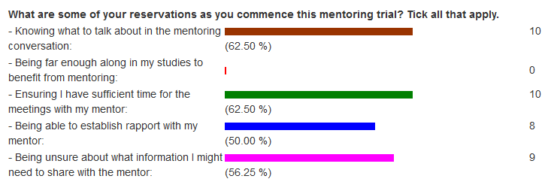

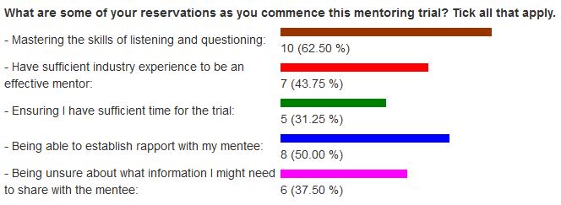

**Figure 2: Pre-mentoring reservations of students (top) and practicing engineers (bottom).**

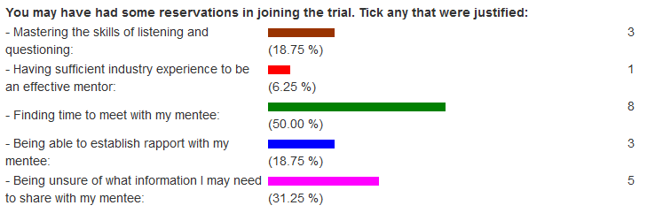

**Figure 3: Post-mentoring assessment of reservations by mentors.**

On the other hand, one student (not the same student) who responded a year after the trial wrote:

For me I had thought that I wanted to do structural engineering so I was paired with a structural engineer mentor. However I soon realized that structural engineering wasn’t what I wanted to do. The mentoring experience helped me think more concretely about my career goals and how the discipline I choose would influence my goals.

The program organizers and the mentors agreed with this assessment. To the more experienced, the role of the mentor is to help the student find their own answers while counselling in ways to avoid problems that may be associated with student misconceptions [20]. There could be a risk that some students will see the role of the mentors to be to make contacts for them or otherwise help them directly in their job, rather than help them in developing skills to succeed. Better communication about the role of mentors seems needed.

One student, a year after the trial, commented “I would have loved to have a female mentor….” We had only 3 women mentors in our pool of 17 volunteers, while 8 women students out of 17, so there was no ability to match all women students with women mentors. Because of the paucity of women engineers with even 10 years of experience, this difficulty will be a common one for student-engineer mentoring programs. Our advice would be to (1) make an extra effort to recruit women engineering mentors, (2) pair all women mentors with women students, and (3) pair students and engineers around personality traits if possible.

One women student commented in the immediate post-trial survey that “I know I am a person of few words but I very often found it difficult to get any words in as the mentor kept talking.” The program organizers noted, during the meet-and-greet session, more than one pairing that seemed to have the potential for difficulty because of a talkative extrovert matched with a quiet introvert. The effect on mentoring of a mismatch was worse in mixed-gender pairs, but seemed to be a potential issue in all matches. If the program organizers are not familiar with the students and engineers, it could be valuable to conduct personality tests on-line prior to matching.

Both mentors and mentees found that the experience was rewarding. Figure 4 shows the assessment of the value of the mentoring trial by the third-year students one year after the mentoring along with the responses by the engineers immediately after. The positive comment on the listening and questioning exercises by both groups is notable, and we would consider the exercises a critical part to an effective mentoring program.

In the pre-trial questionnaire for mentors (results not shown), many mentors noted that they expected to gain from the mentoring experience through a contribution to their CPD record. Although this opinion was more muted after the trial (as shown in Figure 4), we recognize that many potential mentors appear to be drawn to mentoring for CPD reasons. Our experience with the trial supports a conclusion that mentoring schemes should develop the CPD benefits—this could be through a formal recognition of CPD benefits or through university coursework credits.

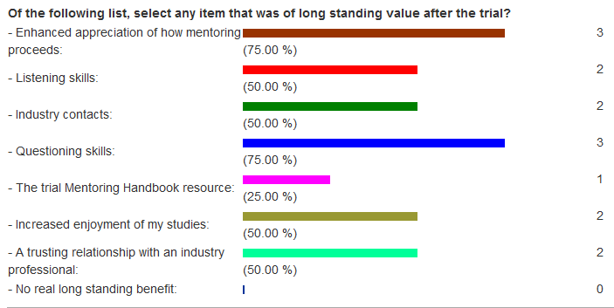

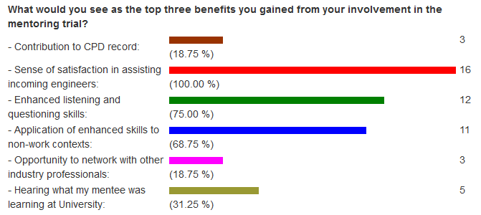

**Figure 4: Post-mentoring benefits and value of the experience to third-year students (one year after, sample of 4) (top) and engineers (bottom, sample of 16). Note: CPD stands for Continuing Professional Development.**

Two specific comments from (third-year) students highlight how students seemed to gain perspective of the broader benefits of mentoring:

When doing an engineering degree (especially in the first 3 years) it’s really hard to figure out where you’re going with it. Most of us don’t have an end goal, and we’re usually just trying to get one assignment in after another, trying to stay afloat in the cut-throat degree system. Most of us just feel like a number in an expensive university which doesn’t do much for us. The mentoring program really helped to make me feel valued. Rather than wondering whether I would get to the end of my degree, I started to look at what I could accomplish after my degree. I didn’t really know what I wanted to do after university, so the mentoring helped me to consider different options. I still don’t know exactly what I want to do, but I have a better understanding of the system now, so I can make more informed decisions about my future. It’s really helpful to have some time to just talk about career paths and goals, even if you don’t come to any conclusions. I feel like a lot of adults hit retirement and feel as though they never accomplished what they wanted in their lives. Having a mentor helps us to figure out what we want and point us more in the right direction. It is an invaluable experience.

Having a mentor gave me motivation to study.

These two student comments support a conclusion that the mentoring program fostered an environment where students felt motivated to continue in their studies because they could see better how they would fit into an engineering future and attain a sense of ‘community’. Similar findings have been argued elsewhere, not least for minority students [11], [21]. It would be valuable to develop this aspect of the mentoring program more in the future. Students also learned much about mentoring as a process from their involvement in the trial. There would seem to be potential to expand the program by having them gain training and experience as a mentor, perhaps to students at an earlier stage in their university engineering education.

One specific issue we wanted the trial to resolve was whether it was better for the university department to run this program for third-year or fourth-year students. Our experiences were that third year would be better in general. Some students noted that they would like to have a mentor in their fourth year that carried over into their future and first full-time job. That type of mentoring relationship appears to be outside of the role that a university can serve effectively—once students graduate, the relationship between the mentor and the graduate become personal and so university emails, on-line resources, and use of staff time and university spaces become problematic. Because there would be value for young graduates to have a mentor when starting employment, there is potential for another institution to organize such a mentoring arrangement.

Our third-year students typically have questions such as these (not direct quotes):

* What fourth year courses should I take? (our students have no optional courses before their fourth year)
* What type of summer work should I try to find?
* Should I go overseas on exchange for a semester in my fourth year?
* Am I as a person going to be welcomed into the civil engineering community?
* How can I stay motivated to get through my courses?

The mentors were able to add perspective to these questions and help students to find their own answers, though it would help them to do so if the organizers of the mentoring program provided more specific support for these questions.

A key finding was that the mentoring seemed more effective for third year students than fourth year students: third year students still faced significant university decisions related to final year optional courses, the type of employment to pursue over the summer and for job interviews, and overseas exchange study. One implication of this finding is a need to better inform practicing engineers of the background associated with these student decisions (e.g., the optional courses available to students).

The mentors were very positive about the trial, with all 16 respondents agreeing that they would be interested in acting as mentor in the future. Mentors saw great benefit in their own professional and personal development by being trained in mentoring, participating in mentoring, and then reflecting on the experience. The benefit to mentors indicates that there is potential in our university offering a fee-based course for practicing engineers in mentoring. This comment from a mentor on our trial is representative:

“Stick at it, it would be good to see this evolve - I think it has so much potential to help mentees and mentors alike!”

5. Conclusions

5.1 Strengths of our trial

* Training in “listening” and “effective questioning” in a workshop format was seen as worthwhile by both mentors and mentees.
* With training and support, participants recognize that mentoring is a learned skill, and that they gain long-term professional benefit from a structured mentoring experience.
* Conducting both before and after surveys helps greatly in assessing what needs to be changed in future years.
* Mentors developed skills particularly through a separate training session and by being asked to reflect on their experiences.

5.2 Areas for improvement

* Communicate more clearly what information is appropriate or inappropriate to share during mentoring.
* Personality assessments of mentors and mentees could assist in avoiding personality mismatches.
* Some third year students felt that mentoring helped them see how they fit into a future engineering career, but this aspect had not been highlighted to them, and greater benefits would be possible with more focus on this benefit.
* Students benefited from being mentored, but would better appreciate the unique nature of the relationship by serving as a mentor.

5.3 Lessons learned

* Mentors and mentees expressed little need for support literature, or university-supported messaging and chat rooms.
* Two months was too short a time to test the full benefit of a professional mentoring scheme.
* Students have a tendency to expect mentors that match their current professional interests and help them directly in their jobs, and considerable effort is needed to have students understand the broader role of mentoring.
* Many women students prefer women mentors, and extra effort is needed to involve women engineers.
* Mentoring with Third Year Civil Engineering students is preferred because of how professional direction for our students is often determined by decisions made before the middle of the fourth year.

5.4 Future efforts

* Reduce the emphasis on on-line resources and chat rooms
* Offer mentoring to some third year students by practicing engineers
* Consider offering mentoring as a course for practicing engineers with course credits that could be applied to masters degrees
* Require third year student mentees to agree to serve as mentors in their fourth year to second year students
* Develop the program so that practicing engineers benefit more directly in terms of credit for continuing professional development.

References

[1] N. J. Balster, C. Pfund, R. Rediske, and J.L. Branchaw, "Entering Research: A course that creates community and structure for beginning undergraduate researchers in the STEM disciplines", *Life Sciences Education,* vol. 9 (2), p 108-118. doi: doi:10.1187/cbe.09-10-0073, 2010.

[2] L. Hui, N. Mickleborough, and B. Chan, "Service Leadership Community: A seedbed for nurturing a service leadership mindset in engineering student learning", Engineering Leaders Conference, 2014.

[3] C. Berry and D. Walter, "ROSE-BUD (Rose Building Undergraduate Diversity) MAPS (Mentoring and Professional Skills)." 12th ASEE Annual Conference & Exposition, 2013.

[4] IPENZ, *Mentoring Guidelines*, Wellington: Institute of Professional Engineers of New Zealand, 2011.

[5] G. Crisp and I. Cruz, "Mentoring college students: a critical review of the literature between 1990 and 2007", *Research in Higher Education,* vol. 50 (6), p. 525-545, 2009.

[6] D. Agholor, A. Lleó de Nalda, and N. Serrano Bárcena, “Mentoring future engineers in higher education: a descriptive study using a developed conceptual framework”, *Production*, vol 27, July 2017. [Online]. Available: <http://www.scielo.br/scielo.php?pid=S0103-65132017000200312&script=sci_arttext>

[7] J. M. Gannon and A. Maher, "Developing tomorrow's talent: The case of an undergraduate mentoring programme", *Education & Training,* vol. 54 (6), p 440-455. doi: doi:10.1108/00400911211254244, 2012.

[8] B. Koehler,, S. Matney, J. Lavelle, and M. Robbins, "Mentor: Motivating engineers through organized relationships", 2007 ASEE Annual Conference & Exposition, 2007.

[9] S. S. Pisimisi and M. G. Loannides, "Developing mentoring relationships to support the careers of women in electrical engineering and computer technologies. An analysis on mentors’ competencies", *European Journal of Engineering Education,* vol 30 (4), p. 477-486, doi:10.1080/03043790500213193, 2005.

[10] D. Jackson, "Making the Connection: the Impact of Support Systems on Female Transfer Students in Science, Technology, Engineering, and Mathematics (STEM)", *Community College Enterprise,* vol. 19 (1), p 19-33, 2013.

[11] C. Poor and S. Brown, "Increasing retention of women in engineering at WSU: A model for a women's mentoring program", *College Student Journal,* vol 47 (3), p 421-428, 2013.

[12] J. Sowers, L. Powers, J. Schmidt, T. Keller, A. Turner, A. Salazar, and P. Swank, "A randomized trial of a science, technology, engineering and mathematics mentoring program", *Career Development and Transition for Exceptional Individuals,* vol 40 (4), p 196-204, 2017.

[13] W. Gray and W. Albert, "Create a STEM pipeline for students who become engineering majors who become engineers", *Leadership and Management in Engineering,* vol. 13 (1), p 42-46, 2013.

[14] Z. Simpson, N. J. van Rensburg, and D. R. Benecke, "Engineering students' visual metaphors for mentorship: Implications for the candidacy period", IEEE Global Engineering Education Conference, 2017.

[15] A. E. Monte, K. A. Sleeman, and G. L. Hein, "Does peer mentoring increase retention of the mentor?", Frontiers In Education Conference - Global Engineering: Knowledge Without Borders, Opportunities Without Passports, Milwaukee, USA, oCT 10-13, 2007.

[16] V. A. Lechuga, "A Motivation Perspective on Faculty Mentoring: The Notion of "Non-Intrusive" Mentoring Practices in Science and Engineering", *International Journal of Higher Education and Educational Planning,* vol 68 (6), p 909-926, 2014.

[17] M. Murray, A. Ross, N. Blaney, and L. Adamson, "Mentoring undergraduate civil engineering students", *Proceedings of the Institution of Civil Engineers - Management, Procurement and Law,* vol 168 (4), p 189-98, doi: doi.org/10.1680/mpal.1400043, 2015.

[18] J. Tolhurst, Coaching for Schools. A Practiced Guide to Building Leadership Capacity, New York: Pearson, 2007.

[19] A. Harney, Essential Aspects of Mentoring Training, Dublin: Engineers Ireland, 2010.

[20] R. M. Marra and R. N. Pangborn, "Mentoring in the technical disciplines: Fostering a broader view of education, career, and culture in and beyond the workplace", *New Directions for Teaching & Learning,* issue 85, p 35, 2001.

[21] J-L. Mondisa and S. A. McComb, "Social community: A mechanism to explain the success of STEM minority mentoring programs", *Mentoring & Tutoring: Partnership in Learning,* vol. 23(2), p 149-163, 2015.