Respiratory system elastance monitoring during PEEP titration

YS Chiew¹; JG Chase¹; GM Shaw³; T Desaive³
¹Mechanical Engineering, University of Canterbury, New Zealand
²Intensive Care Unit, Christchurch Hospital, New Zealand
³Hemodynamic Research Center, University of Liege, Belgium

Introduction
PEEP selection during mechanical ventilation (MV) for patients with ALI/ARDS remains a challenge for clinicians. Clinicians often rely on experience and intuition in setting MV, resulting in a more variable treatment and outcome. We hypotheses that, monitoring patient-specific respiratory system elastance, Ers during PEEP change may provide an insight to patients’ condition.

Methods
13 patients with ALI/ARDS underwent a step-wise PEEP increase (5cmH2O) recruitment manoeuvre (RM) until peak airway pressure reaches 45cmH2O. Airway pressure and flow were recorded using a pneumatachometer. The change of patient’s respiratory system elastance (Ers=1/compliance) and end of expiratory lung volume, EELV during RM were estimated and studied. The trials were approved by New Zealand South Island Regional Ethics Committee.

Results
Median [IQR] Ers over all patients were 34.0cmH2O/l [IQR: 26.1-51.0], reflects the heterogeneity of the patients and their response to PEEP. This outcome supports the idea that PEEP should be individualised. During RM, patients’ Ers decreased with PEEP increase until a specific minimum and increase later at higher PEEP. The decreased of Ers suggest alveolar recruitment whereas increase of Ers at higher PEEP shows potential over-inflation. An example is shown in Figure (a). A clear inflection/ minimum Ers can be found in (a), indicating a potential method to optimise PEEP selection for particular patient. Figure (b) shows the change of patient’s EELV with PEEP increase. As PEEP increases, the potentially recruitable collapse lung decreases.

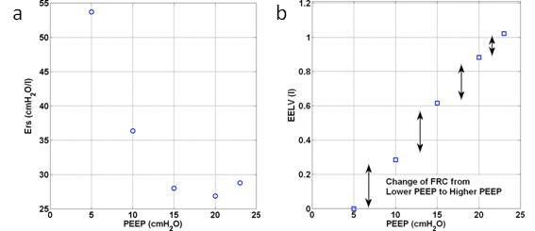
Figure: Ers and EELV change with PEEP increase

Conclusion
The change of patient-specific Ers with EELV during minimally invasive PEEP titration provides an insight to the patient lung condition, thus potentially be used as a method to individualise MV treatment and in particular, PEEP selection.

